
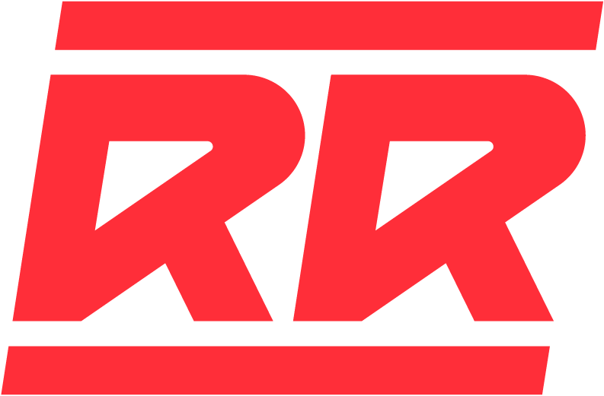 BEHAVIOR POLICY

A child participating in the B&O Railroad Museum’s Sensory Summer Camp and exhibiting aggressive behaviors will not be banned or expelled from the program. If your child has exhibited aggressive behaviors at home or school, please disclose this information to camp staff on the child’s registration form or in conversation over phone or email. All of your child’s information will be kept confidential and will only be shared with Summer Camp counselors and aides working with your child. Please share the specific behavior (hitting, biting, etc.), any antecedents/triggers (sensory overload, denying access, etc.), and behavioral management strategies. It is important for Camp staff to have a full picture of the behavior to best support your child and keep all campers safe. Providing staff with as many details as possible gives your child the best chance at a successful and fun camp experience.

In order to keep all campers, camp staff, and museum visitors safe, our policy is as follows:
If a child behaves aggressively towards another child or adult, their parent/guardian will be immediately notified. The camper will be separated from other children to give them an opportunity to cool down and communicate with their counselor. Staff will follow recommendations made on camper information forms for assisting with cool down and preventing escalation. In recognition of the emotional regulation challenges Neurodivergent children face, the camper will be allowed to return to camp and continue full participation. For the safety of all campers, if the aggressive behavior is repeated or escalated, a parent/guardian will be contacted and the camper will be asked not to return to camp that week. If registered for any subsequent weeks of Sensory Summer Camp, the child may return during another week with full participation.

